**SALES DATA SQL QUERIES**

**KEY PERFORMANCE INDICATORS**

1. Total Revenue

SELECT SUM(total_price) AS Total_Revenue from sales_data

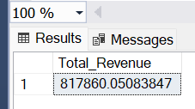

1. Average Order Value

SELECT SUM(total_price)/COUNT(DISTINCT order_id) as Avg_Order_Value from sales_data

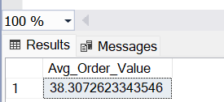

1. Total Pizzas Sold

SELECT SUM(quantity) AS Total_Pizza_sold from sales_data

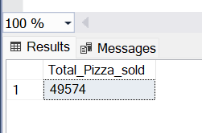

1. Total Orders

SELECT COUNT(DISTINCT order_id) AS Total_orders from sales_data

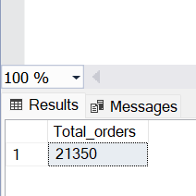

1. Average Pizzas Per Order

SELECT CAST(SUM(quantity) AS DECIMAL(10,2))

/CAST(COUNT(DISTINCT order_id) AS DECIMAL(10,2)) AS Avg_Pizzas_Per_Order from sales_data

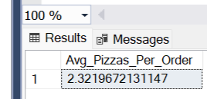

**CHART REQUIREMENTS**

1. Daily Trend for Total Orders

SELECT DATENAME (DW, order_date) as order_day, COUNT(DISTINCT order_id) AS Total_orders from sales_data

GROUP BY DATENAME(DW, order_date)

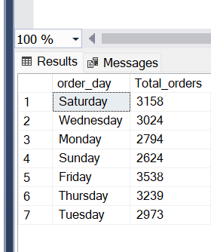

1. Hourly Trend for Total Orders
2. SELECT
3. DATEPART(HOUR, order_time) AS [order-hours],
4. COUNT(DISTINCT order_id) AS Total_orders
5. FROM
6. sales_data
7. GROUP BY
8. DATEPART(HOUR, order_time)

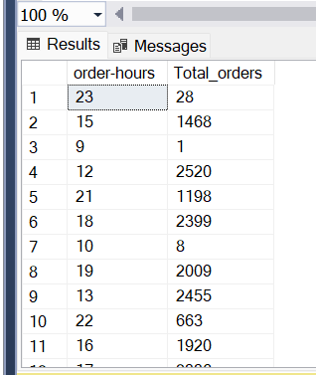

1. Percentage of Sales by Pizza Category